Wire frames

A wireframe is the first step in the UX design workflow of a website or mobile application. the concept of creating a wireframe is similar to how architects start with blueprint drawings and engineers sketch mechanical diagrams.

Types of wireframes

There are three main types of wireframes

**Low fidelity wireframes**

**Medium fidelity wireframes**

**High fidelity wireframes**

The fidelity spectrum for and prototypes is vast. The UX design workflow will typically include paper sketches, basic low fidelity wireframes and high fidelity, interactive wireframes or prototypes

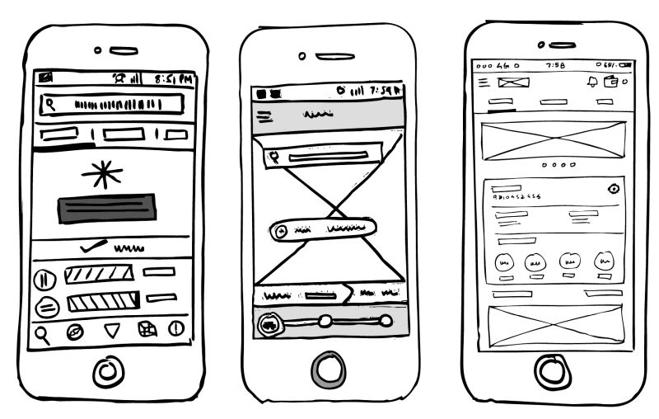**Low -fidelity wireframes**

Low-fidelity wireframes are basic visual representations of the webpage and usually serve as the designs starting point. as such, they tend to be fairly rough, created without any sense of scale, grid, or pixel- accuracy. There are a few ways to include low fidelity wireframes in the UX design process. Some designers will start by sketching out their web or mobile interfaces screens on paper – these sketches are often referred to as paper wireframes. they are typically concept sketches, a set of drawing or storyboard, representing the skeleton of the interface.

Low fidelity wireframes, omit any detail that could potentially be a distraction and include only simplistic images, block shapes, and mock content such as filler text for labels and heading.

Low fidelity wireframes are useful for starting conversations, deciding on navigation layout, and mapping the user flow in short low fidelity wireframes are ideal if you’ve got at stakeholders or clients in the room and you want to sketch something up with a pen mid meeting. they’re also incredibly useful for designers who have multiple product concepts and want to quickly decide which direction to go down.

. **High - fidelity wireframes**

High fidelity wireframes boast pixel specific layouts. Where a low fidelity wireframes may include pseudo ladin text filters and grey boxes filled in with an X to indicate an image , high fidelity wireframes ideal for exploring and documenting complex concepts such as menu systems to interactive maps

High fidelity wireframes should be saved for the latter stages of the products design cycle.

****Medium to high fidelity wireframes or prototypes are more complete representations of the end a product than low fidelity wireframes. Many are clickable and respond to the users, actions mimicking authentic interface interaction. Their aesthetics and content are more precise than lower down the fidelity spectrum as designers concentrate on refining the graphics spacing and UI layout.

High fidelity wireframes are often built in the advanced stages of the design process to communicate design decisions to the development team prior to coding the final product.

Additionally, they help validate complex interactions during use testing. these wireframes provide, test participants with realistic representation of what the product will look and feel like as well as how it will respond to them. designers usually use different tools for depending on what kind of wireframe they want to build ranging from low to medium to high fidelity.

**Low fidelity vs high fidelity wireframes**

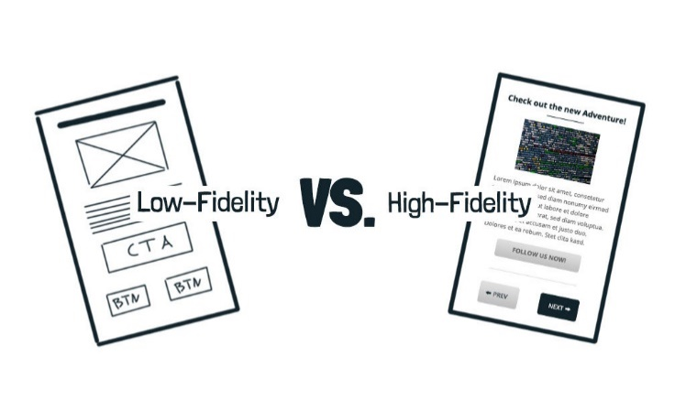The most important difference between low fidelity and High fidelity wireframes is how they contribute to the overall user experience. low fidelity wireframes can be an excellent way of visualizing requirement and getting everyone on the same page early on.

High fidelity wireframes will make sure that your design decisions are communicated to the team building the end product and that target users are accounted for.

However both low fidelity wireframes and high fidelity wireframes and high fidelity wireframes are fundamental phases in the web design process. Without basic wireframes you are putting your team at risk of repetition and misunderstanding. without basic wireframes, you are putting your team at risk of repetition and misunderstandings. without clickable wireframes, user testing want be accurate and your user experience may suffer. be smart and include both in your design process.

Some examples of low fidelity wireframes and high fidelity wireframes



**Low fidelity wireframes** can be an excellent way of visualizing requirements and getting everyone on the same page early on.

**High fidelity wireframes** will make sure that your design decisions are communicated to the team building the end product and that target users are accounted for**.**

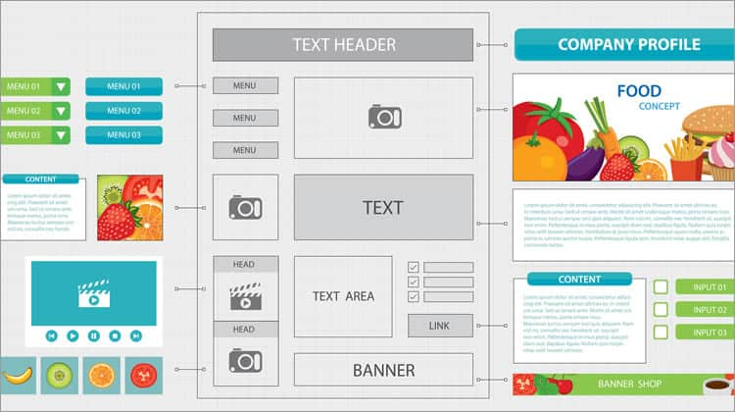

**High fidelity wireframes using Smart UX**